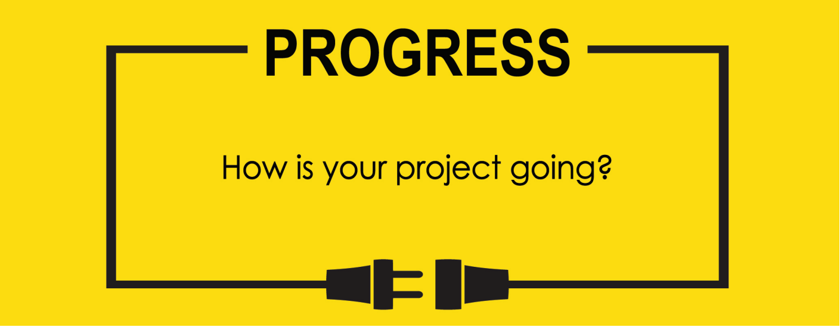

**Name:**

**Project Title:**

**Previous Goals**

What were your three goals from last week? Were you able to complete them? If so, select Completed. If not, select the level of completion and explain in the Notes section why the goal was not completed, what still remains to be done, and when you expect to finish work on the goal.

Goal #1 from last week:

**Status:** _____Completed _____Partially Completed _____No Progress

**Notes:**

Goal #2 from last week:

**Status:** _____Completed _____Partially Completed _____No Progress

**Notes:**

Goal #3 from last week:

**Status:** _____Completed _____Partially Completed _____No Progress

**Notes:**

**Next Three Goals**

Choose three subtasks from your Gantt chart and use them to form goals that you plan to complete this week. In the text box beneath each goal, give details about what you plan to accomplish. Include details such as what materials are needed, how many hours each day you plan to devote to the task, and so on.

NOTE: THESE ARE INDIVIDUAL GOALS THAT YOU PLAN TO ACCOMPLISH. THESE ARE NOT TEAM GOALS.

**Goal #1:**

**Goal #2:**

**Goal #3:**